Drieam

Edita Pronckutė

Semester 8

28/02/2023

Design Document



This document is a record of the steps I took to gather inspiration to improve the Evidence dashboard. It consists of the following sections:

* Other E-portfolios
* File Managers
  + Mobile File Management applications
  + Desktop file management applications
* Current Portflow Look
  + Portflow Evidence Designs (made by company’s UX designer)
  + Dashboard inspiration
  + Smart Table inspiration
* My Designs
* Summary

The document is filled with snapshots of examples and brief explanations. In the end, I summarize the process and conclude the findings.

# Other E-portfolios

Most of the competitor LMSs or eportfolios are not freely accessible to view, however, some of them offer a demo to try out. Below are some of the snippets of the similar applications the focus is on the aggregated data display and options.

**EPASS** was started in 2008 by the Department of Educational Development and Research of Maastricht University. It offers an eportfolio for Health, Medicine and Life Sciences studies.

Image 1. Epass portfolio for medical students

**Educator** is a student information system for secondary, higher and private education. The Leermeter is a part of the Educator though can be used as standalone too. It is a great progress tracking tool that aids in assessments and reviews.

Image 2. Educator Leermeter functionality

**Mahara** is a modular eportfolio tool first established in 2006 in New Zealand. It is a stand-alone system where students can upload evidence of their work to showcase for assessment and reviews with multiple people.

Image 3. Mahara e-portfolio web app

**Moodle** is a free open source learning platform designed to provide educators, administrators and learners with a system to create personalized learning environments. Moodle is an LMS and Portflow can be integrated to work with it as it does not have an explicit portfolio functionality.

Image 4. Moodle LMS demo where student can submit only what is expected

Paragin offers a **MijnPortfolio** product among other things that gives students and professionals to showcase their work for performance assessment, potential jobs and demos. It does look rather like a resume.

Image 5. MijnPortfolio by Paragin example

**Sakai** is an open source LMS that offers eportfolio functionality among other things. It is developed by educators for various educational institutions. There is an extensive documentation on how to set up and use the LMS whether as an institution or as an individual.

Image 6. Sakai dark mode resource management page

**Simulise** is a digital portfolio, students can store and beautifully display all types of materials. In addition, it offers many opportunities to demonstrate and develop competencies and skills. This eportfolio is the quite similar to Portflow is several features such as feedback, parts of the portfolio can be made public as a showcase, skills development, rubric scales etc.

Image 7. Simulise portfolio example

### Conclusion

The students are always able to upload files (word processing documents, spreadsheets, slide presentations, audio and videos, web links). They can then organize these files and links into folders and subfolders making it easier to locate and access items. It is also common to allow users to upload multiple files using the Drag and Drop interface.

Thus, various document types are uploaded to the digital portfolios, the files are typically grouped in collections (folders, sections, theme’s etc.), therefore a good way to display (list) the contents is per their collection. There is also data available for each file, such as name, type, size, date-created, collections, semester and tags. It would be a good idea to offer filtering based on these parameters next to a name search option.

# File Managers

In addition to existing e-portfolios and LMSs the student reviewed file managers as the Evidence section is about the convenient aggregated data management and display.

## Mobile File Management applications

It is worth to looking into mobile solutions too as they tend to be more compact and neater than the file managers for computers. Below are the popular android file management tools. Left to right: Google Drive, Files (for internal storage by google) and Files (default Android file manager).

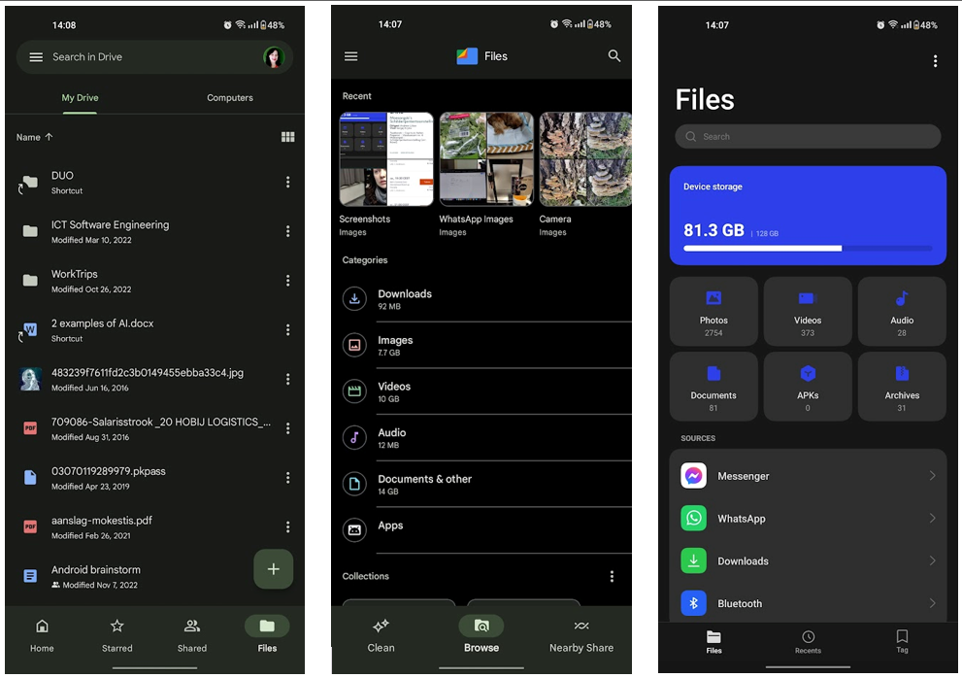

Image 8. Examples of file manager apps on mobile

## Desktop file management applications

**Opus12** is a replacement for a default file explorer for windows. It offers way more functionality and features.

Image 9. Opus12 file manager for windows

**Windows File Manager** is a remake of the file manager of older windows version of 1990s. It has been brought up to life since 2019 and is applicable to win10+ offering original and some added features.

Image 10. Windows file manager example

**Xplorer2** is another file manager for windows OS offering a large variety of features including a custom categorization.

Image 11. Xplorer2 file manager with a variety of features

### Conclusion

File managers seem to offer many features that would be very overwhelming for the Evidence section, however, some ideas are worth exploring:

* File map to show where the file is within the rest,
* Viewing by (list, icons, info),
* Sorting by (size, name, date),
* Filtering by (date, name, collection, type),
* Preview section
* Hovering over the file for information or display details in a separate section.

These are common through all file managers offered one way or the other and it can really help in managing aggregated data.

# Current Portflow Look

It is also important to take in how the current Portflow application looks and what if offers. Next to that, there have already been several sketches made by the UX designer, I used them for inspiration as well.

Image 12. Portflow look at the time of writing this document

## Portflow Evidence Designs (made by company’s UX designer)

**Option A:** Includes Goals and Collections, however, the large dropdowns add clutter and make it seem like an unfinished form. There are more things that could be added to offer more functionality.

Image 13. Portflow design by UX designer option A

**Option B:** Looks tidier, however it is not clear how to add or link new collections and goals. It could use a “add” or “+” buttons.

Image 14. Portflow design by UX designer option B

**Option C:** Offers clear add buttons, however, the overview is still scarce, lacking more functionality to help manage the evidence in a meaningful and convenient way.

Image 15. Portflow design by UX designer option C

## **Dashboard inspiration**

The dashboard inspiration was gathered from online available examples, another Drieam’s product – Study Coach and checking AntDesign guidelines (which is applied on all Drieam’s products).

Image 16. Study Coach and an online executive dashboard examples

Image 17. AntDesign dashboard guideline example

## **Smart Table inspiration**

The ideas for the improving the table mostly came from AntDesing at it is already used on all Drieam’s products and still offers variety of features. Moreover, EduFrame, another one of Drieam’s products has a lot of successfully implemented and tested tables. They are highly functional and yet still have a sleek minimalistic look about them, most importantly they are clear for the user. Lastly, I followed some guidelines from Pencil&Paper.io (a Canadian UX design company).

Image 18. AntDesign table example with sort and filter functions integrated into the table.

Image 19. Table design by pencil&paper.io demonstrating sorting and filtering

Image 20. Table design by pencil&paper.io advising to show applied filters above the table.

Image 21. EduFrame table example with date-time picker.

# My Designs

### V1

This version was meant to take what already is and only add only several features from my requirements. I chose to use the existing table but use the space better by offering more overview with more information available at a first glance. Below are the version and comment counters, feedback status (newly added to Portflow), linked goals and even a bulk delete option. However, the goals work differently than I anticipated initially, they can only be added in the context of a collection and cannot exist without one.

### V2

Version 2 was a dive into change of view options. Inspired by Desktop file management applications (view as detailed list vs thumbnails). The idea was to view the content in a form of cards yet still offer a bit more insight (such as version, comment counts and feedback status). The cards would be grouped per folder to indicated what is where and how many times. However, there is no overview of goals (as goals work differently than collections) and no date filtering or sorting of any kind.

### V3

For this version UX designer encouraged to explore the file trees/maps as per inspiration from other file managers. It can be a very useful tool that helps see the context of the file. However, the Evidence section does not have a deep hierarchical file structure, therefore, it was challenging to apply this. Below is an attempt maintaining the card structure. The feedback received from my peers however stated that it is not clear how to use it and that a different behavior is expected.

### V4

Version 4 is about taking the best from the first three and adding a bit of “dashboardiness” as per the vision of Product Owner. The cards above are counters that serve as buttons filtering the overview table underneath (also offering important insight into loose evidence - orphans).

### V5

This version was focused on making the table as smart and functional as possible. AntDesign already offers most of the smart features, why not integrate it? The table is sortable, filterable and even has a search option integrated. The applied filters change the data (counters) in the dashboard above.

### V6

This version has a smart table from before but also offers a much nicer dashboard look. However, the checkboxes are typically the first column. In addition, all search, filter and sort buttons are integrated into the table making it slightly more complex and not noticeable at a first glance.

### V7

This version offers more overview in the table, but also a dashboard that summarizes the results. The search and date filter options are pulled out of the table to clearly indicate what the user can do. The Clear Filters reminds user that there are filters applied.

This way the core features are highlighted, the general overview is quite detailed and there is even a summarized data above that could be applied as filters in the best case scenario.

# Summary

Most e-portfolios lack proper data aggregation management tools (meaning students lack control over the content once it is uploaded). Which is important for Portflow. However, it is quite common to offer default sorting by different evidence types (pptx, image, text file, video etc.). Most of the examples offer quick upload or moving options via drag & drop.

Exploring file management solutions offered more insights as not every eportfolio applications even allows students much freedom to manage their own content as Portflow. In addition, most of them are not accessible for an outsider to review too. File manager application is more of a solution for the My Evidence section as it exactly meant to manage aggregated data. Some of my early designs were inspired by file managers (V3 with the file tree). It also helped me to keep focus on filtering and sorting features and make sure it stays included in my solution.

Next to exploring the possibilities of similar solutions, I also focused on what there is now and how could it grow from there. For this purpose, I reviewed the existing designs made by the teams UX designer. Moreover, during the whole design process I stayed in frequent communication with PO, UX designers and developers too. This way I stayed close to the product vision and their experience and guidance really helped me improve. They advised to look into the dashboards and tables as well as gave me general tips and suggestions. The addition of dashboard offers great insight, and it could be used for filtering and sorting the evidence too. Together with the table it makes for a very informative and functional page.

### Sources

Crawshaw, F. V. (2021, March 24). *Enterprise Filtering: UX Pattern Analysis*. Retrieved from Pencil and Paper: https://pencilandpaper.io/articles/ux-pattern-analysis-enterprise-filtering/

Educator B.V. (2004-2023). *Leermeter: Ik breng mijn ontvikkeling in beeld!* . Retrieved from Educator: https://www.educator.eu/leermeter/

Epass. (2010-2023). *Information*. Retrieved from epass: https://www.epass.eu/en/about-epass/mission-en-vision/

GPSoftware. (2022). *Directory Opus 12*. Retrieved from GPSoftware: https://www.gpsoft.com.au/

IBM. (2023, Jan 12). *Managing aggregated data views*. Retrieved from IBM: https://www.ibm.com/docs/en/qsip/7.4?topic=tasks-managing-aggregated-data-views

Klipfolio Inc. (2001-2022). *Dashboard Examples and Templates*. Retrieved from Klipfolio: https://www.klipfolio.com/resources/dashboard-examples

Mahara. (2023). *Portfolios for your learning community*. Retrieved from Mahara: https://mahara.org/

Moodle. (2023). *Welcome to the Moodle community*. Retrieved from Moodle: https://moodle.org/

PagerDuty Inc. (2023). *What is Data Aggregation?* Retrieved from PagerDuty: https://www.pagerduty.com/resources/learn/what-is-data-aggregation/

Paragin Group. (2023). *MijnPortfolio*. Retrieved from Paragin: https://www.paragin.nl/mijnportfolio/

Sakai. (2023). *Great For Learning*. Retrieved from Sakai LMS: https://www.sakailms.org/

Sakai. (2023). *Sakai Community Documentation*. Retrieved from Sakai: https://sakai.screenstepslive.com/s/sakai_help

Simulise. (2023). *Het digitaal portfolio*. Retrieved from Simulise: https://www.simulise.com/

XTech. (2023). *Design language and framework*. Retrieved from AntDesign: https://4x.ant.design/

Zabkat. (2022-2023). *Xplorer²*. Retrieved from Zabkat: https://www.zabkat.com/sshots.htm